Captain App Link

Overview: This document provides the steps to download the Captain App. The Captain App is a paid Marketplace service offered by Petpooja.To download the Captain App, users must first log in to the Petpooja Dashboard.
Note: The Captain App download link will only be available if the Captain App service has been activated for the outlet. If the service is not activated, the download option will not be displayed.

Step 1: Login Petpooja Dashboard URL: billing.petpooja.com
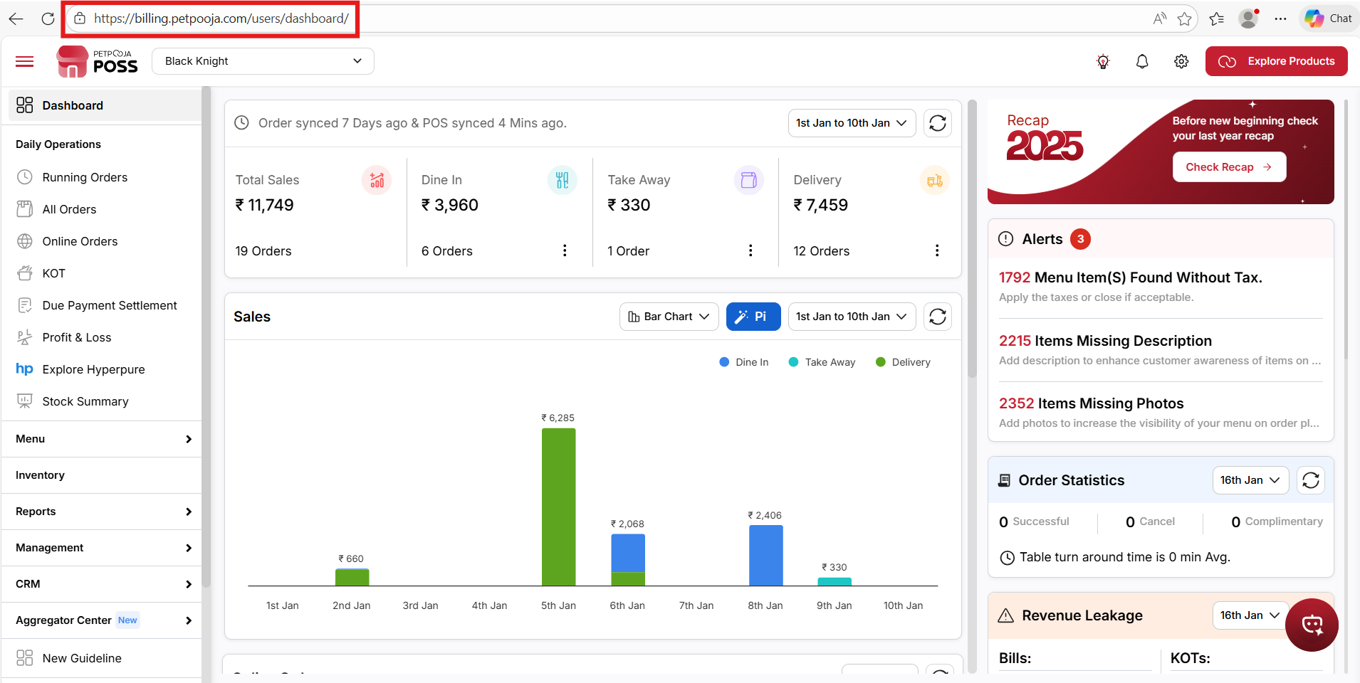
{ Image Name: PetPooja Dashboard,
Description: The image shows the PetPooja "Outlets Statistics" dashboard accessed via a web browser, as indicated by the URL. Here is an image of step 1 Billing.petpooja.com in Steps to reach Captain app link }

Step 2: Click on the Settings option, and then select the Petpooja Apps section.
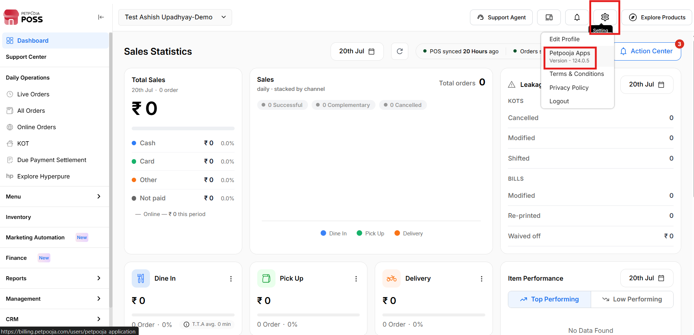
{Image Name: PetPooja Apps,
Description :Here is an image shows of In the top right corner, the "Setting" button under that Petpooja Apps is prominently highlighted in red.Here is an image of step 2 Dashboard into reach Captain app link }

Step 3: On Petpooja Apps section page Captain Ordering.
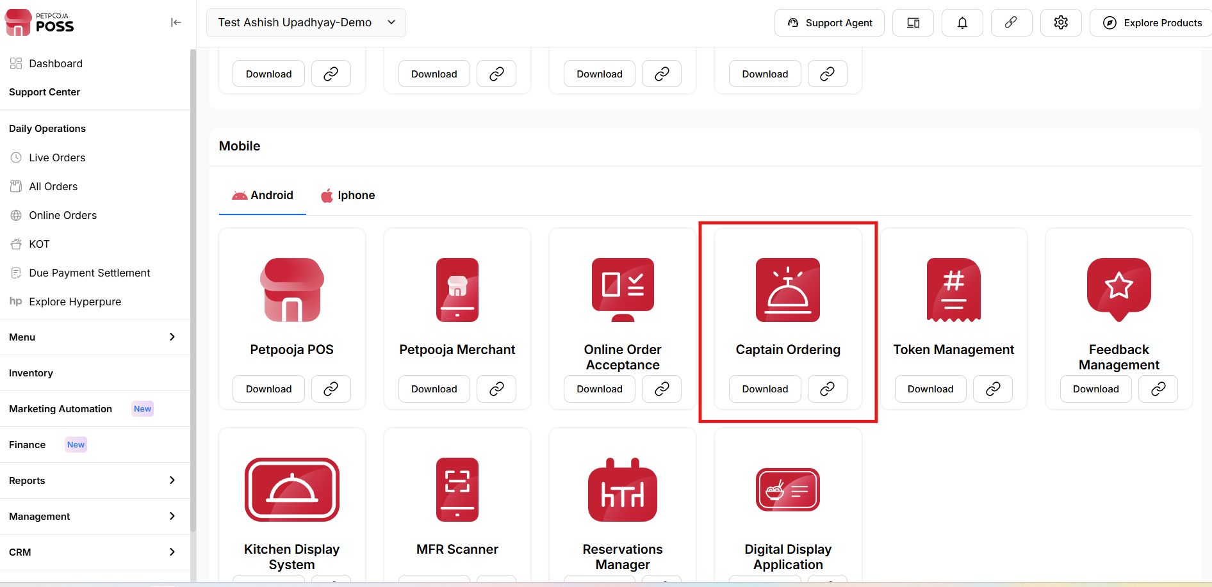
{Image Name: PetPooja Apps Link,
Description : Here is an image showing Captain App Link or can download click on Download Button. This is located under the Mobile App section }

